Action Bladder Cancer UK   
6 Trull Farm Buildings  
Tetbury GL8 8SQ

T: 0300 302 0085

29.04.2025

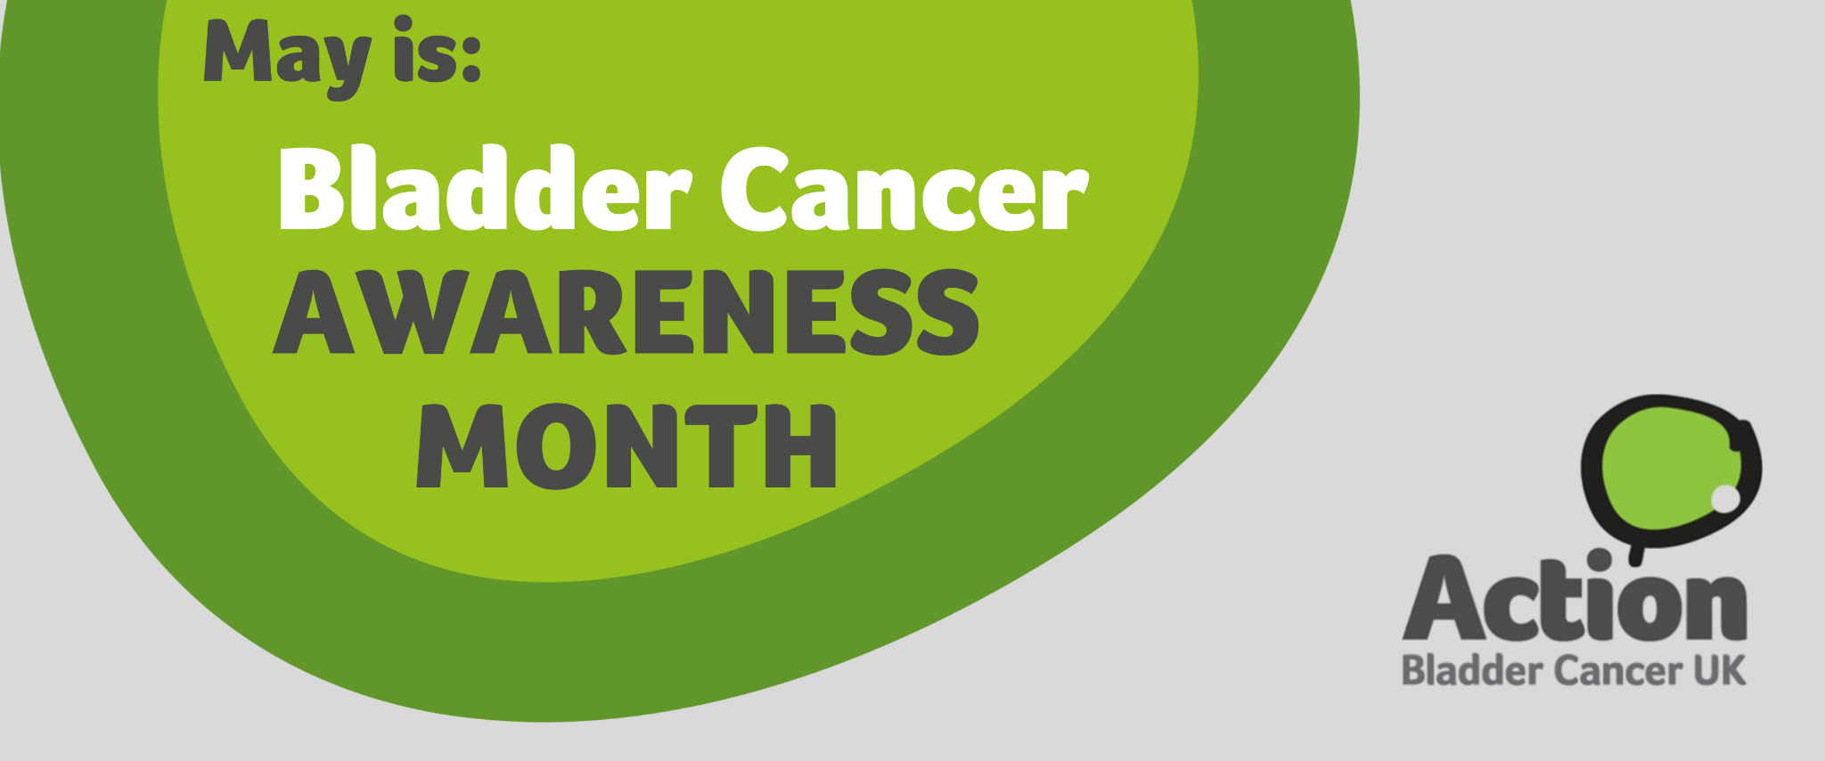

**Action Bladder Cancer UK Urges People to Know the Signs of Bladder Cancer for Awareness Month**

This May, [Action Bladder Cancer UK](https://actionbladdercanceruk.org)(ABC UK) is urging the public to learn [the signs of bladder cancer](https://actionbladdercanceruk.org/symptoms/), one of the UK’s most common yet often overlooked cancers, and to find out more about the vital work ABC UK does to support patients, raise awareness, encourage research, and campaign for better treatments and earlier diagnosis.

In the UK, over 20,000 people are diagnosed with bladder cancer each year, yet it is still not widely recognised as a common cancer. The main symptoms include:

* Blood in the urine (even if only once);
* A persistent or recurrent need to pass urine more often or more urgently; and
* Pain or discomfort in the pelvic area.

Action Bladder Cancer UK recognises the vital role that health professionals play in raising awareness and encouraging early diagnosis. During Bladder Cancer Awareness Month, ABC UK is encouraging specialist nurses, GPs and other health professionals to actively promote awareness of bladder cancer symptoms, helping more people recognise the signs and seek timely medical advice.

Everyone can play a part in raising awareness of bladder cancer, whether by running information stands, encouraging workplaces to share resources online, promoting messages on social media, sharing information with networks, or organising fundraising events. Action Bladder Cancer UK provides free support materials such as printed leaflets, pens, lanyards, badges, T-shirts, and digital assets to help make your efforts impactful.

Jeannie Rigby, Action Bladder Cancer UK CEO says: “Recognising the symptoms of bladder cancer is key to early diagnosis. Unfortunately, some cases can be diagnosed late, leading to worse outcomes. Bladder cancer can be overlooked, particularly in women, where symptoms can be confused as urinary tract infections or gynaecological issues. It's important to never ignore blood in your urine. Be aware of the signs, and visit your GP if you have any concerns”.

For further information on how you can [get involved](https://actionbladdercanceruk.org/get-involved/) in Bladder Cancer Awareness Month and support ABC UK, [order your resources and merchandise](https://actionbladdercanceruk.org/order-materials/) or download shareable [social media assets](https://actionbladdercanceruk.org/awareness-month/), visit the website or email [info@actionbladdercanceruk.org](mailto:info@bladdercanceruk.org).

For more information about Action Bladder Cancer UK and our work visit [www.actionbladdercanceruk.org](http://www.actionbladdercanceruk.org).

--------------------------------------------------- ENDS-----------------------------------------------

About Action Bladder Cancer UK:

ABC UK’s mission is to support bladder cancer patients and their families, raise awareness of the disease to improve early diagnosis and outcomes, and support research into bladder cancer.

**For media inquiries, please contact:**

Press enquiries -

E: info@actionbladdercanceruk.org

T: 0300 302 0085

W: www.actionbladdercanceruk.org

Registered charity: 1164374